AIM:-car parking …………..

CIRCUIT DIAGRAM: 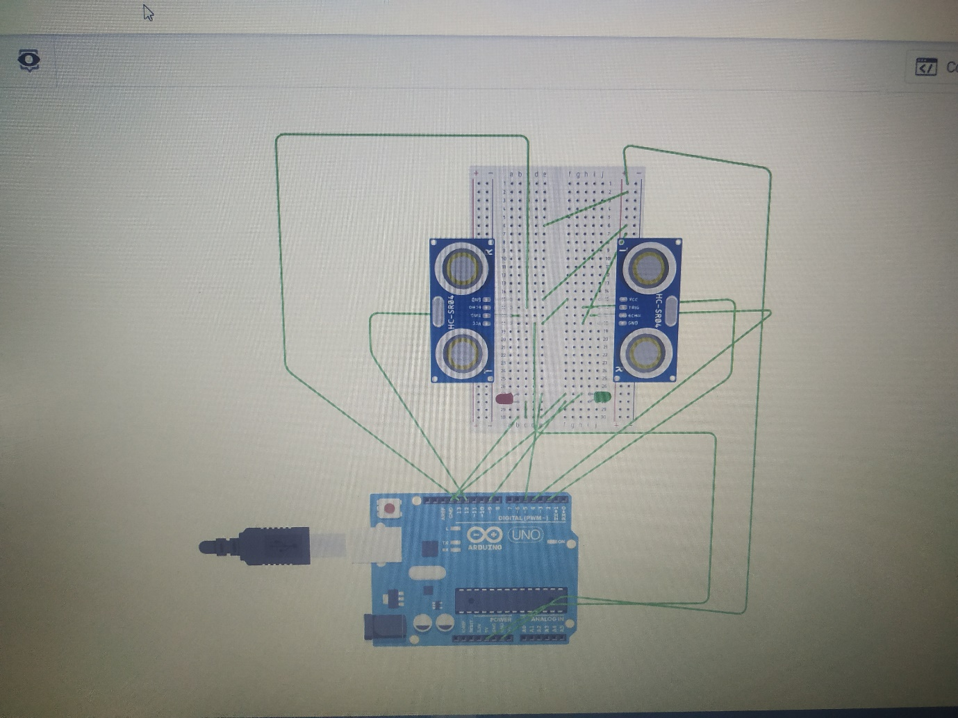

THEORY:- **Light dependent resistor** works on the principle of photo conductivity. Photo conductivity is an optical phenomenon in which the materials conductivity is increased when light is absorbed by the material.  
When light falls i.e. when the photons fall on the device, the electrons in the valence band of the semiconductor material are excited to the conduction band. These photons in the incident light should have energy greater than the band gap of the semiconductor material to make the electrons jump from the valence band to the conduction band. Hence when light having enough energy strikes on the device, more and more electrons are excited to the conduction band which results in large number of [charge carriers](https://www.electrical4u.com/mobility-of-charge-carrier/). The result of this process is more and more [current](https://www.electrical4u.com/electric-current-and-theory-of-electricity/) starts flowing through the device when the circuit is closed and hence it is said that the [resistance](https://www.electrical4u.com/electrical-resistance-and-laws-of-resistance/) of the device has been decreased. This is the most common working principle of LDR

PRECAUTIONS:-

Do not use a voltage in excess of the operation voltage range.  
Appying a voltage in excess of the operation voltage range, or applying AC power (100 V AC or greater) to a DC power model sensor may result in explosion or fire.

Do not short-circuit the load. Explosion or fire may result.

Do not reverse the power supply polarity or otherwise wire incorrectly.  
Explosion or fire may result.

If the power supply is connected directly without a load, the internal elements may explode or burn. Be sure to insert a load when connecting the power.